**Saint Basil's Cathedral, Russia**

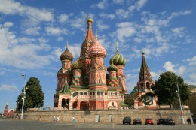

Saint Basil's Cathedral is a Russian Orthodox Church built in 16th century in Moscow. It is operated as State Historical Museum and is a property of Russian Federation. The design of the building forms a shape like that of flame of bonfire rising to the sky.

Saint Basil's Cathedral is a UNESCO World Heritage Site